**UI Validations**

1. Add employee screen is not showing error after clicking on Add button without filling the form
2. After entering numbers in the first name and last name and entering alphabets in Dependents box upon clicking on Add button it does not show error or any validations
3. There are no validations on add employee form ie, whether Name should be alphabets only, dependents should be numbers only, no of limits on character entered in all three fields, and combination of alpha numeric and special character etc
4. After adding an Employee the first name and last name is displayed in reversed ordered ie, first name is displayed under last name and last name is displayed under first name.
5. Update employee screen also behaves same as add employee screen where if any of the field is not entered and upon clicking updated button the screen does not display any error message or validation message
6. After clicking on update button, the form title is add employee. Should it be update employee?
7. When updating an employee with dependents it allows up to 32 dependents but when entering 33 dependents it does not display any error message or any validation message on the screen. In short more than 32 dependents are not allowed.

**API Validations**

1. Without AuthToken or with wrong AuthToken it is giving 500 internal server error, but it should give 401 unauthorized error
2. Post call without body gives server error, but it should be 400 bad request error, PUT also behave same
3. Put call to an existing employee update salary to 0.0 and also affects other calculations.
4. Post call creates an employee with reversed ordered ie, first name is displayed under last name and last name is displayed under first name on UI.
5. Get call after deleting an existing employee using delete call, gives 200 ok instead of 404 not found error.

STEP TO REPRODUCE BUGS:

**Bug :1** Add employee screen is not showing error after clicking on Add button without filling the form.

Steps to recreate:

Login into Benefits dashboard using valid credentials.

Click on Add employee button.

Add employee window pops up. Click on Add button without entering anything.

Error message should be displayed for the required field.

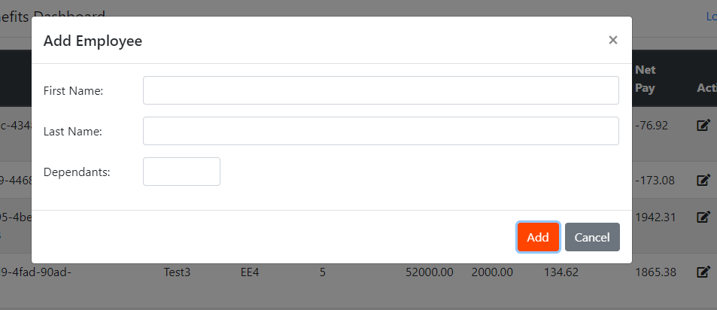

**Bug 2**: After adding an Employee the first name and last name is displayed in reversed ordered ie, first name is displayed under last name and last name is displayed under first name.

Steps to recreate:

Login into Benefits dashboard using valid credentials.

Click on Add employee button.

Add employee window pops up. Enter First name as Test1 and Last name as EE1.

Click on OK.

Last name is displayed as Test1 and First name as EE1 i.e reversed.

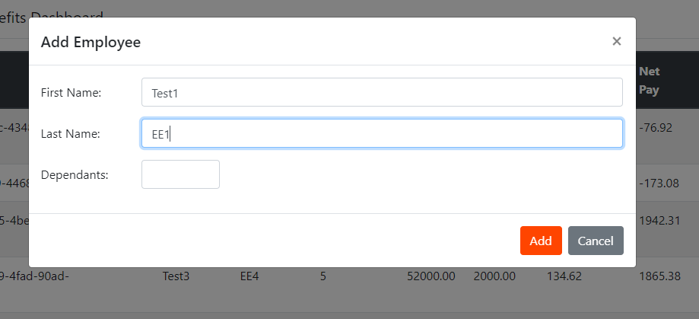

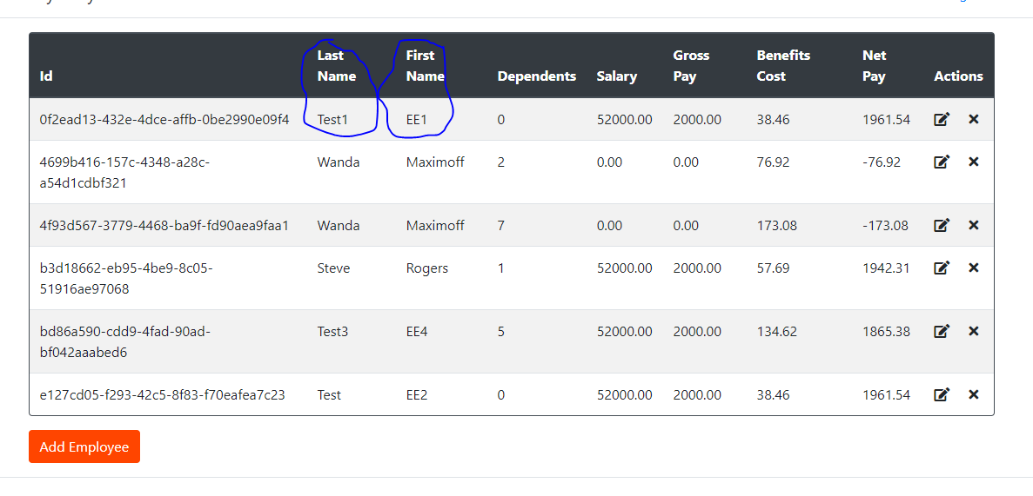

**Bug 3:** Get call after deleting an existing employee using delete call, gives 200 ok instead of 404 not found error.

Steps to recreate:

Click on New button located on the left upper side and click on HTTP request.

Select delete from dropdown and enter request URL: [https://wmxrwq14uc.execute-api.us-east-1.amazonaws.com/Prod/api/employees/{{id}}](https://wmxrwq14uc.execute-api.us-east-1.amazonaws.com/Prod/api/employees/%7b%7bid%7d%7d)

Provide basic Auth token in Headers.

Click on Send button. Status code ok is displayed.

Now change the request to GET instead of delete from dropdown.

Status code should be 404 instead of 200.

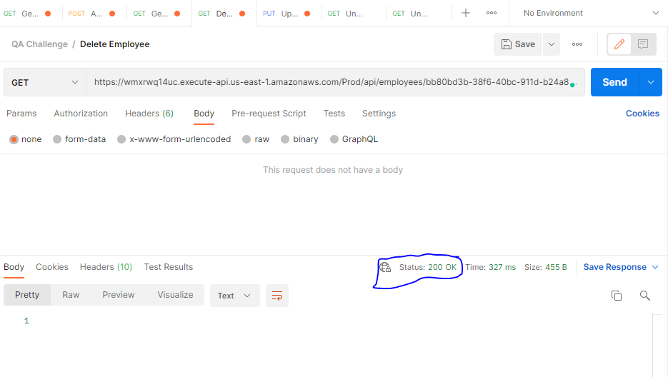

**Bug4**: Put call to an existing employee update salary to 0.0 and also affects other calculations.

Create a Put Http request. Provide basic auth in headers.

Enter URL: [https://wmxrwq14uc.execute-api.us-east-1.amazonaws.com/Prod/api/employees/{{id}}](https://wmxrwq14uc.execute-api.us-east-1.amazonaws.com/Prod/api/employees/%7b%7bid%7d%7d) (id of an employee)

Under Body, select raw and JSON from dropdown and paste the below text:

{

    "id": "4f93d567-3779-4468-ba9f-fd90aea9faa1",

    "firstName": "Wanda",

    "lastName": "Maximoff",

    "dependants": 7

}

Click on send button.

The console output should be salary 52000 and gross pay should be 2000.

